25. Email Alert, Evaluation Criteria - 29 March 2022

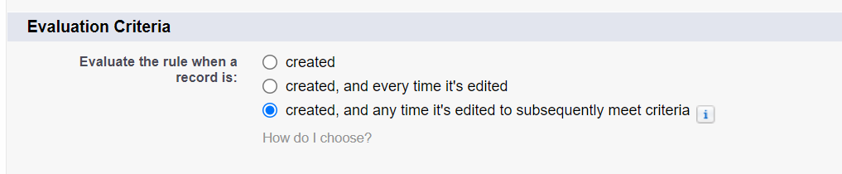



|  |  |
| --- | --- |
| Every time It’s Edited | Sub Sequently Edited |
| Workflow Runs whenever a record is edited and condition satisfied. | Workflow only run when a record is edited and condition satisfied from FALSE 🡪 TRUE |

3] Created and Any Time It’s Edited to sub-sequently meet the criteria.

User Story:

Send Case Escalation Email When a Case gets Escalate.

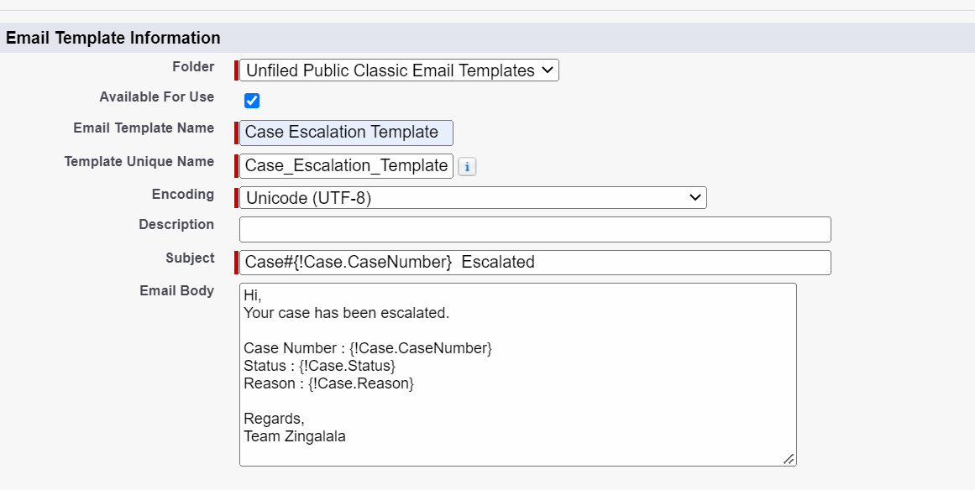

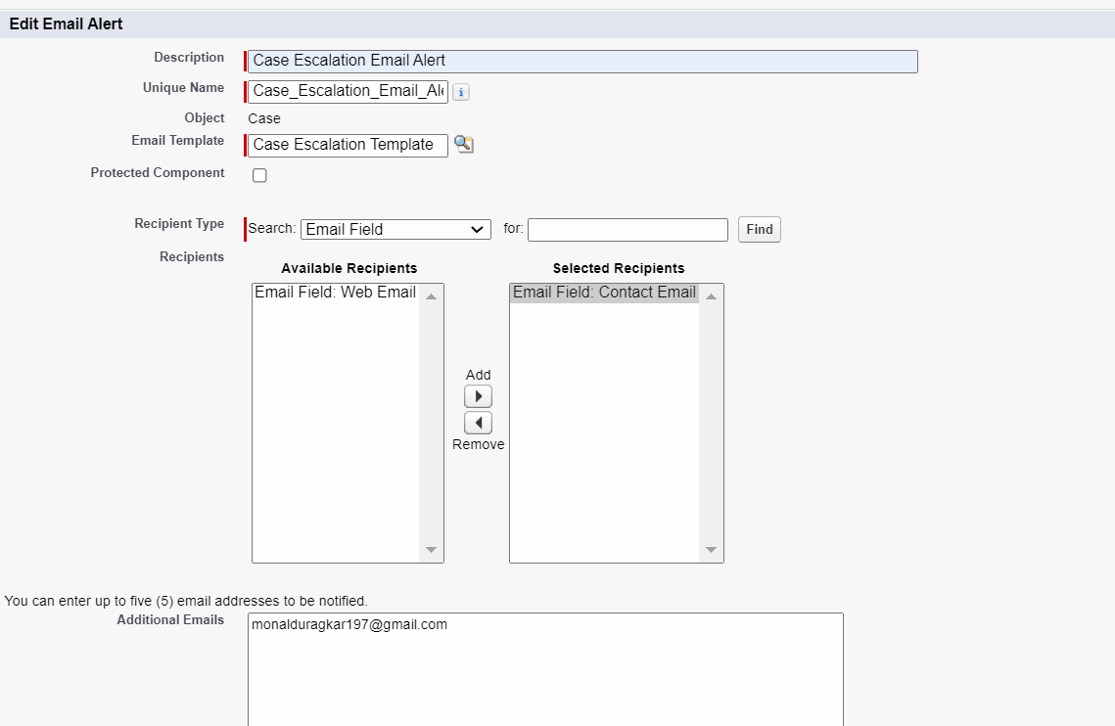

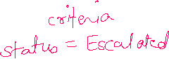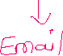

Created and Every Time It’s Edited to sub-sequent meet the criteria.

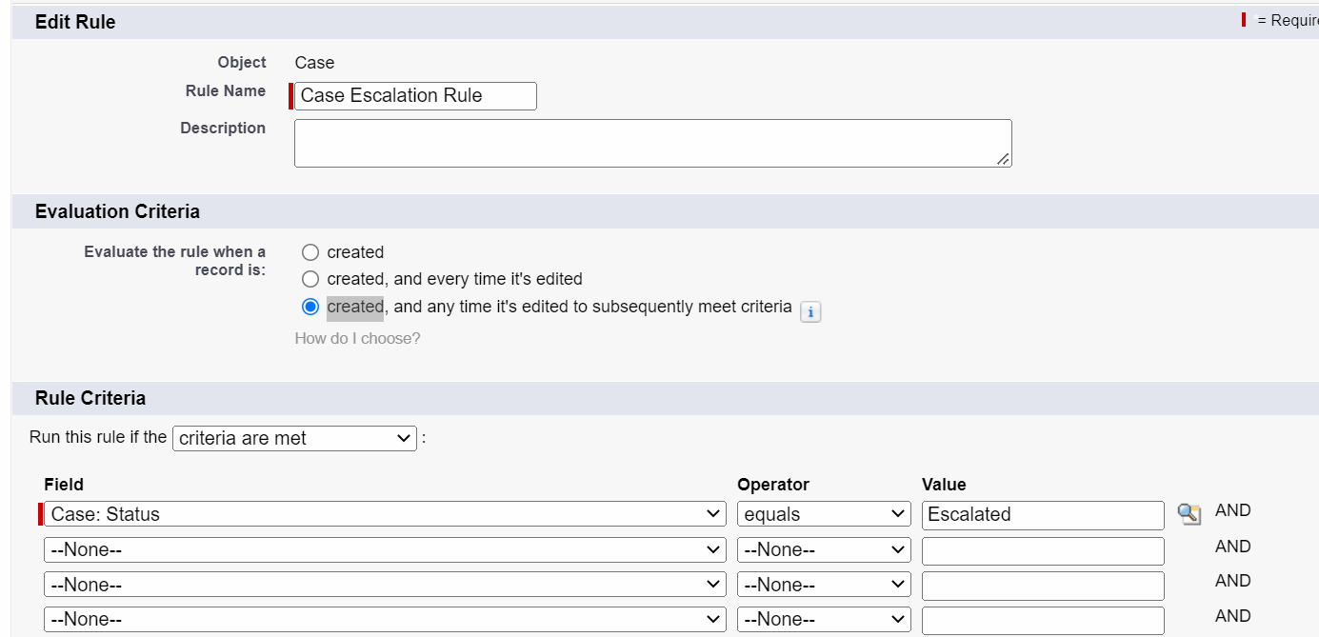

1] Created

New 🡪 TRUE 🡪 **YES**

2] Sub Sequent Edited

**FALSE 🡪 TRUE 🡪 YES**

|  |  |  |  |
| --- | --- | --- | --- |
| **Type** | **Previous Condition** | **New Condition** | **Action** |
| NEW | **TRUE** | | **YES** |
| Edit | **TRUE** | **TRUE** | **NO** |
| **Edit** | **TRUE** | **TRUE** | **NO** |
| **Edit** | **True** | **FALSE** | **NO** |
| **Edit** | **FALSE** | **TRUE** | **YES** |
|  |  |  |  |

|  |  |  |  |
| --- | --- | --- | --- |
| **Type** | **Previous Condition** | **New Condition** | **Action** |
| New | **FALSE** | | **NO** |
| Edit | **False** | **False** | **No** |
| **Edit** | **False** | **True** | **YES** |
|  |  |  |  |
|  |  |  |  |
|  |  |  |  |



Assignment:

1] Send Welcome to Police Station Email when Applicant is Eligible for Police Verification.